MUHAMMAD TAUFIQ BIN JURIMI

A21EC0095

TUTORIAL 3B SCREENSHOTS

T3b-1.html

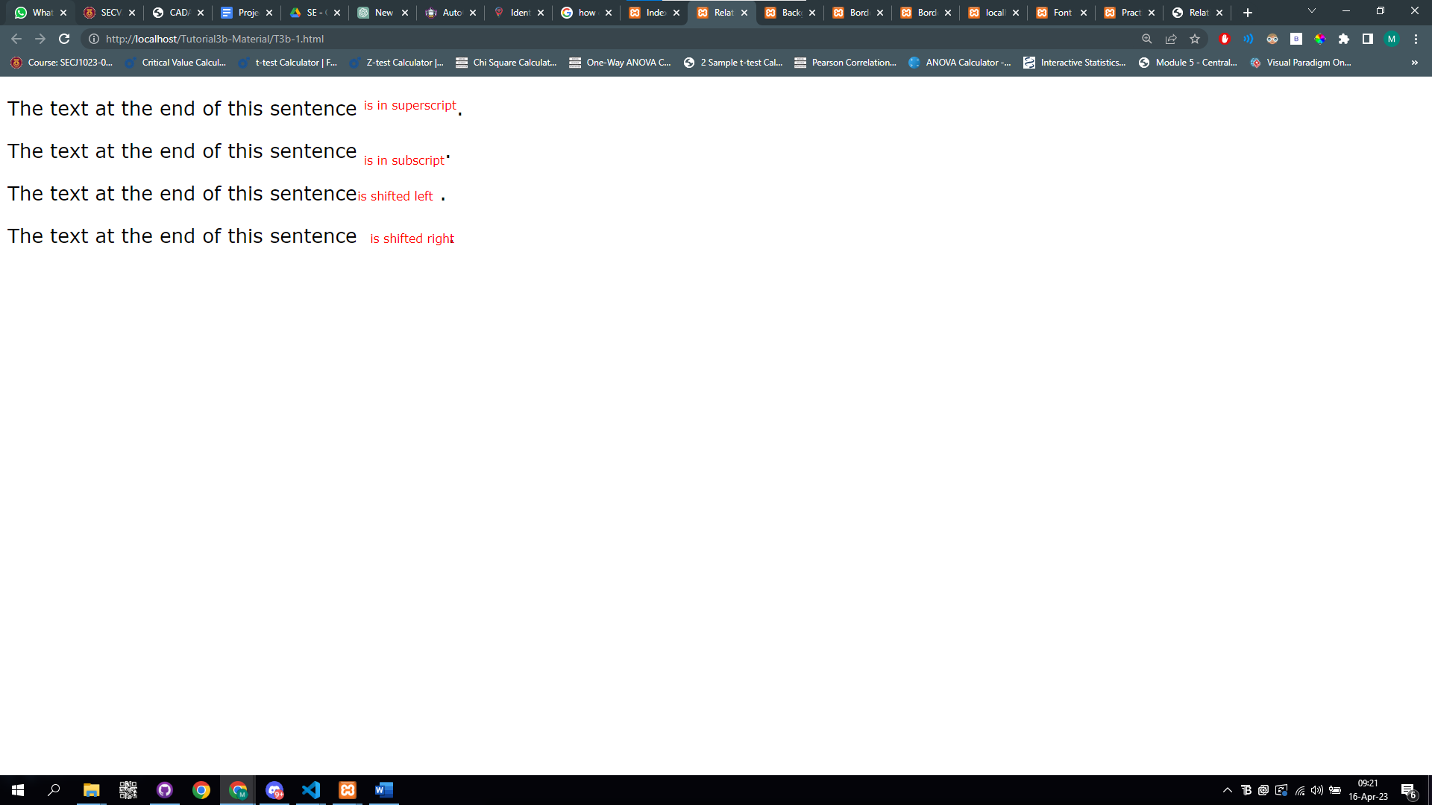

T3b-2.html

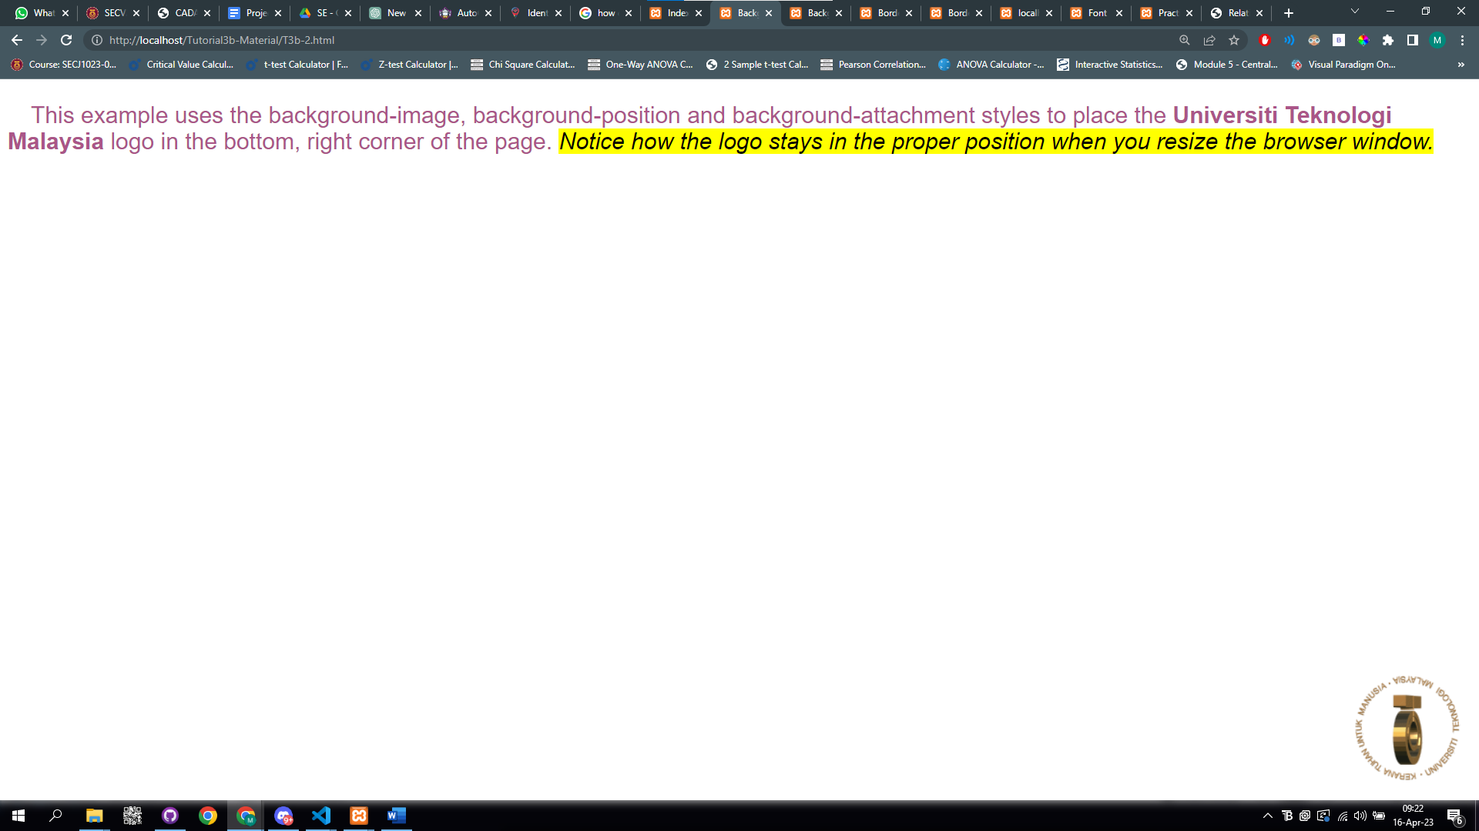

T3b-3a.html

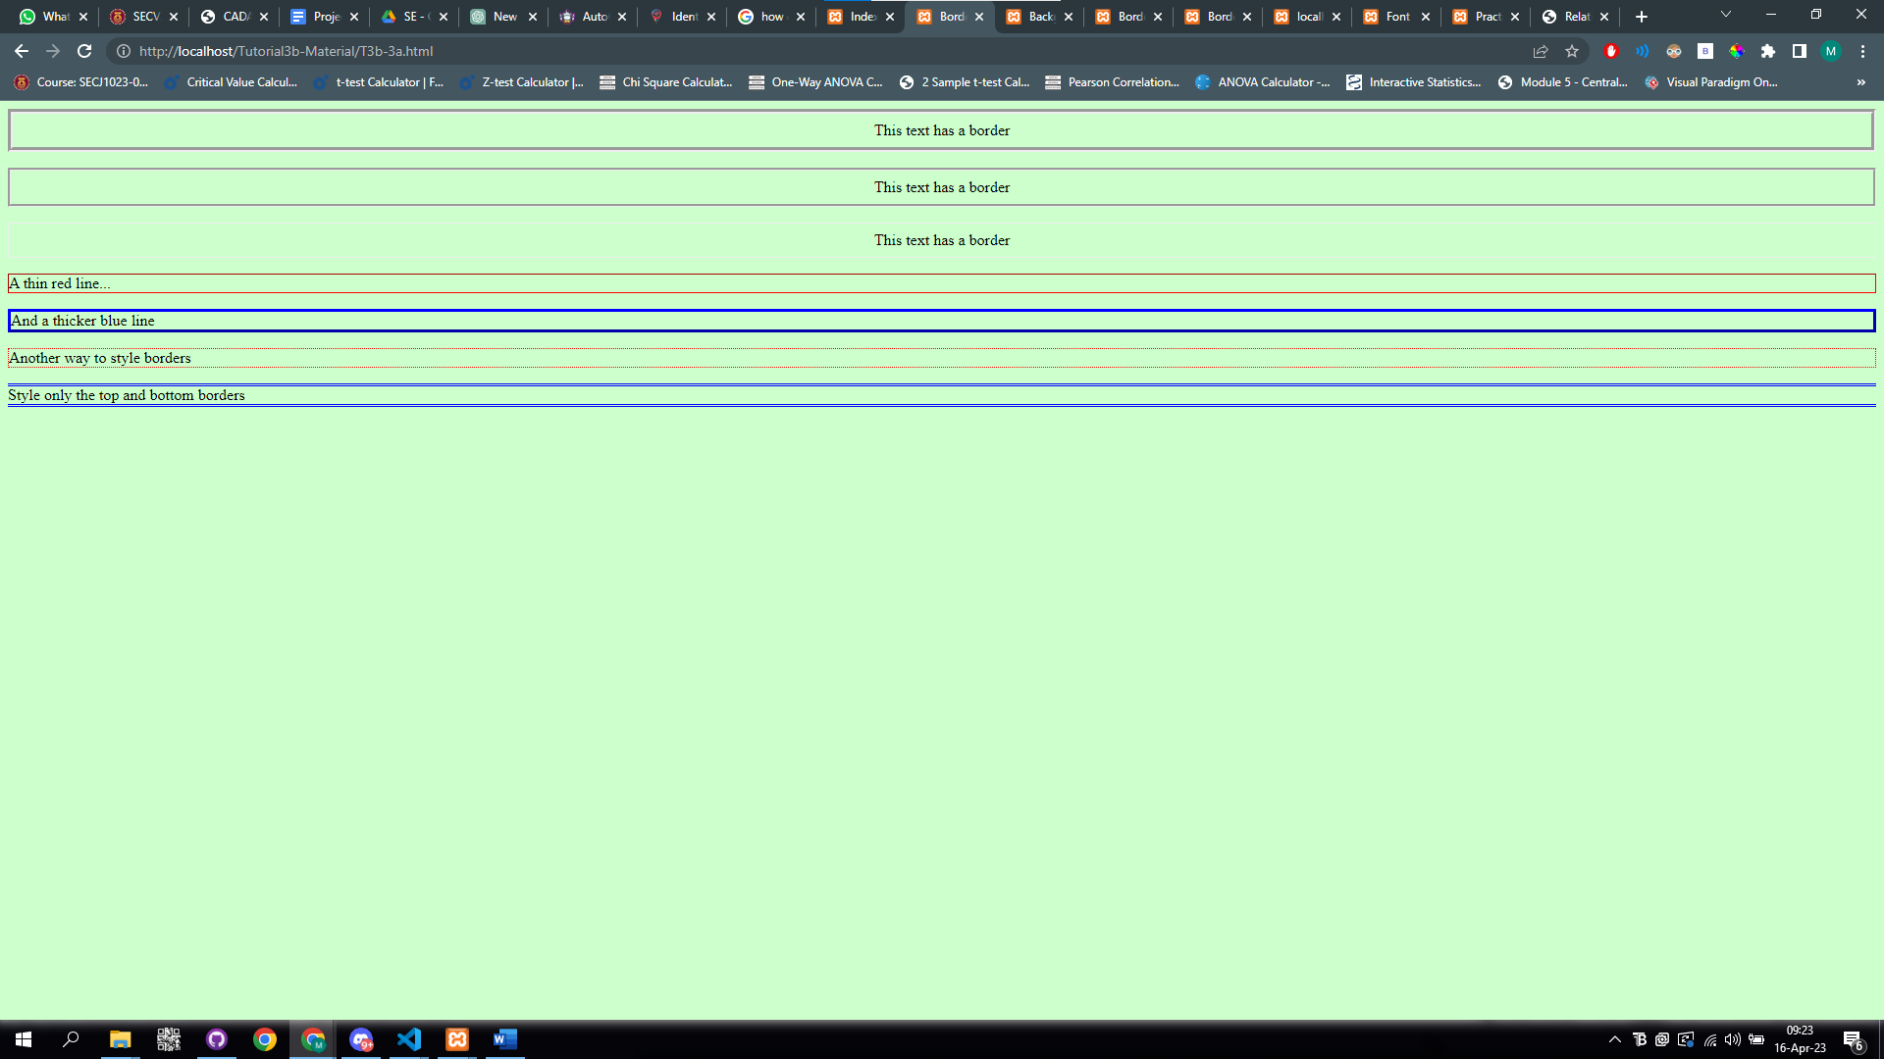

T3b-3b.html

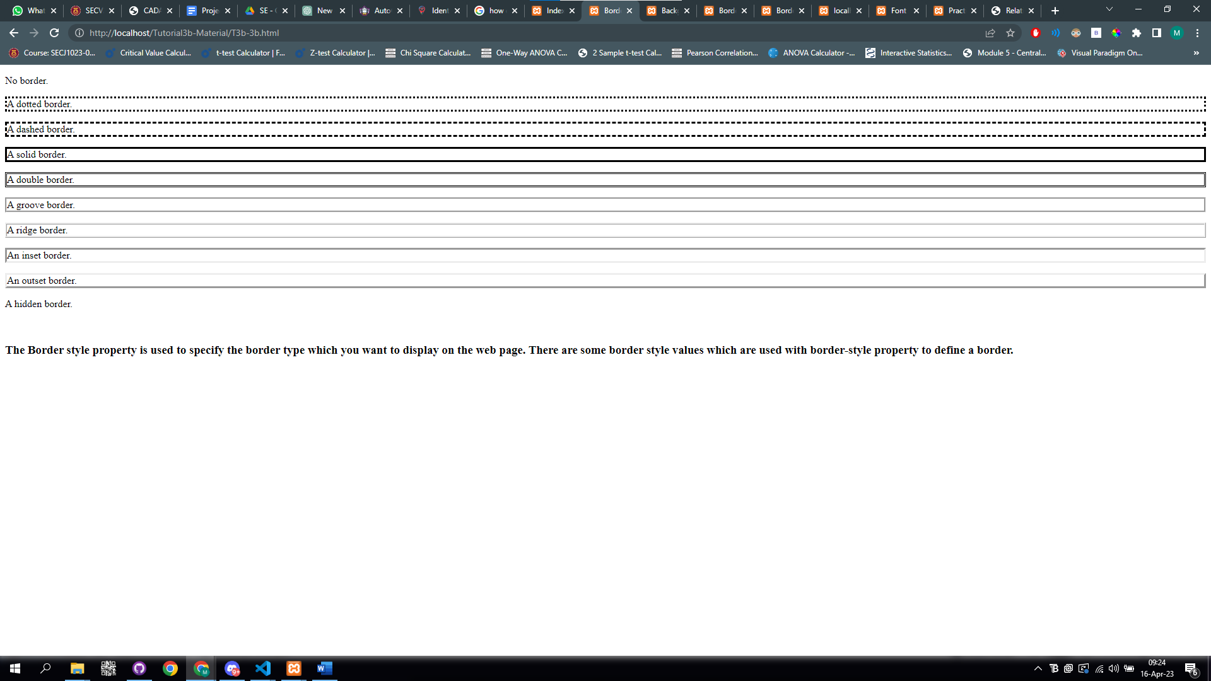

T3b-4.html

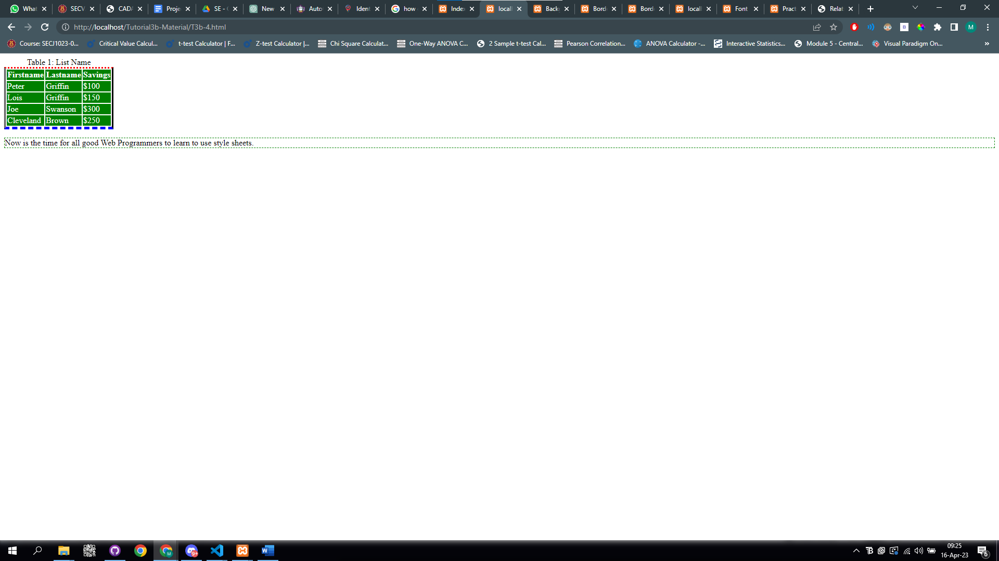

T3b-5.html

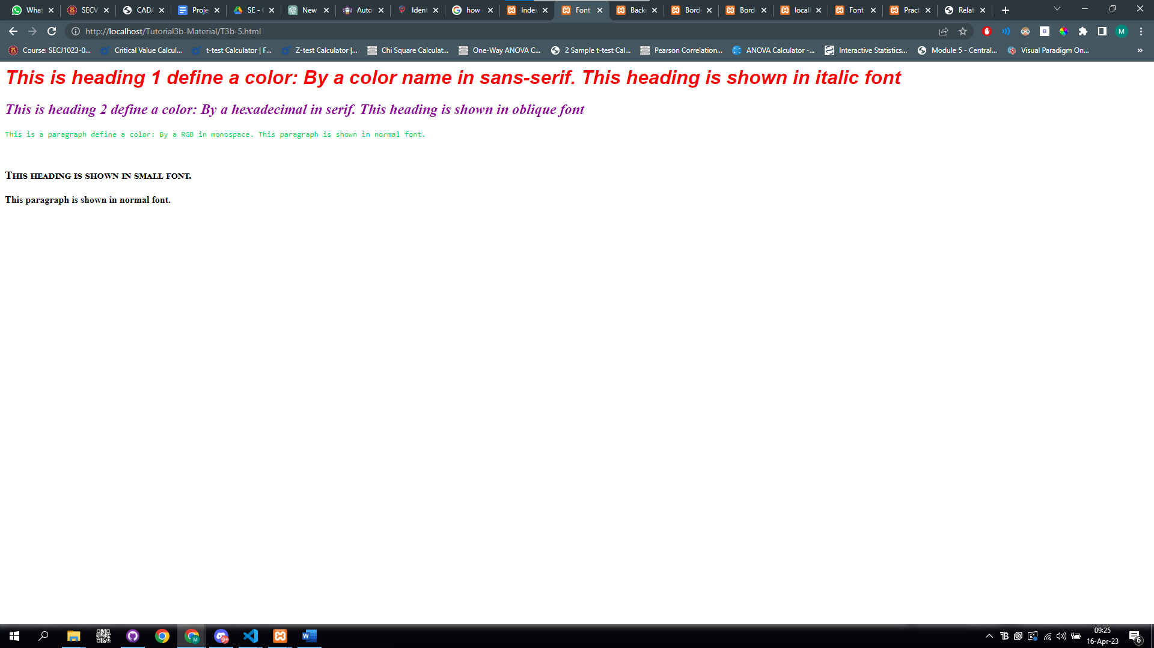

T3b-6.html

